**Drone Assisted Stream Habitat (DASH) Protocol, DRAFT**

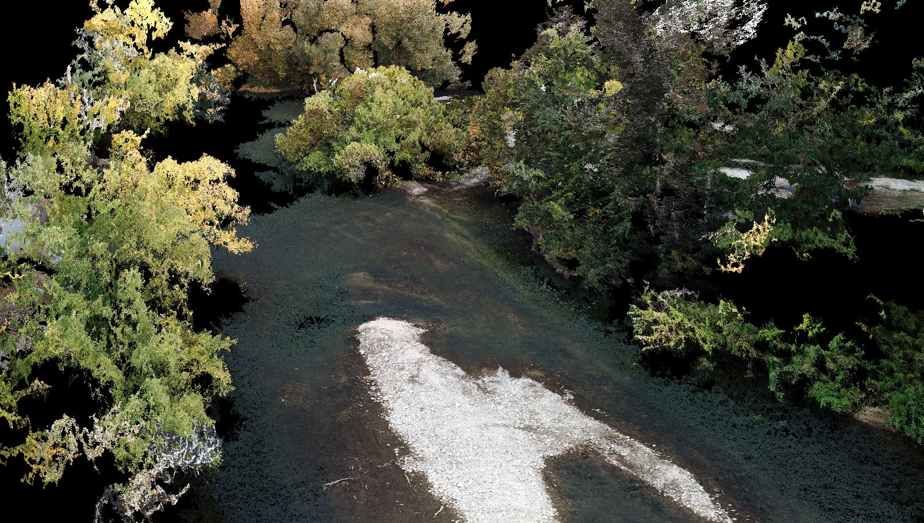

**May 2019**



**Drone Assisted Stream Habitat (DASH) Protocol, DRAFT**

**Prepared By:**

Richard A. Carmichael1, Michael W. Ackerman1, Kevin See1, Braden Lott1, Tulley Mackay1, and Chris Beasley1

1Biomark, Applied Biological Services, 705 South 8th Street, Boise, Idaho 83702

**May 2019**

**Table of Contents**

[Executive Summary 1](#_Toc1033735)

[Generated Habitat Attributes 1](#_Toc1033736)

[Locating Sites 2](#_Toc1033737)

[Site Layout 4](#_Toc1033738)

[Channel Segments and Side Channels 4](#_Toc1033739)

[Channel Unit Delineation 8](#_Toc1033740)

[Channel Unit Delineation Steps 10](#_Toc1033741)

[Habitat Data Collection 13](#_Toc1033742)

[Large Woody Debris 13](#_Toc1033743)

[Undercuts 16](#_Toc1033744)

[Substrate Composition 17](#_Toc1033745)

[Pebble Cross Sections 17](#_Toc1033746)

[Ocular Substrate Estimates 20](#_Toc1033747)

[Riparian Cover 21](#_Toc1033748)

[Solar Access 21](#_Toc1033749)

[Drone Survey 22](#_Toc1033750)

[References 24](#_Toc1033751)

[Appendix A. Habitat Metrics 25](#_Toc1033752)

**List of Figures**

[Figure 1. Decision tree outlining segment number and channel unit designations adapted from CHaMP (2016). 7](#_Toc1033753)

[Figure 2. How to number channel segments within a site. The main channel is assigned segment 1 throughout the site. Both large and small side channels are assigned sequential segment numbers working upstream. In the figure, channel segment numbers are preceded with a “S” (S1-S3) and channel unit numbers with a “U” (U1-U13). Adapted from CHaMP (2016). 8](#_Toc1033754)

[Figure 3. Representation of pool A) cross-sectional (lateral) and B) longitudinal concavity. 9](#_Toc1033755)

[Figure 4. Channel unit perimeter delineation. Adapted from CHaMP (2016). 11](#_Toc1033756)

[Figure 5. Dichotomous key of criteria used to classify Tier I (Slow Water/Pool, Fast Water, and Small Side Channel) channel units. Adapted from CHaMP (2016). 12](#_Toc1033757)

[Figure 6. Depiction of diameter and length measurements locations for LWD with attached roots. 13](#_Toc1033758)

[Figure 7. Decision tree to evaluate whether wood debris qualified as qualifying large woody debris (LWD). Also shown are data to collect from individual LWD pieces. 15](#_Toc1033759)

[Figure 8. Example of a cross-section layout. In this example, distance between samples is 1 m, because the bankfull width is 12 m. Particle sample location is shown with a circle and crosshairs. Figure from CHaMP 2016. 18](#_Toc1033760)

[Figure 9. Gravelometer used to classify the b-axis of particles. 19](#_Toc1033761)

**List of Tables**

[Table 1. A list of indicators used to properly identify the bankfull elevation within your survey site. Adapted from CHaMP (2016). 3](#_Toc1033762)

[Table 2. Criteria used to delineate and classify channel units. 11](#_Toc1033763)

[Table 3. Size categories for sediment in the range of silt/clay to bedrock. Record the size range that the particle falls within (e.g., 45-64). Adapted from CHaMP (2016). 19](#_Toc1033764)

[Table 4. Ocular substrate size classes. Estimate b-axis diameter of particles. 20](#_Toc1033765)

# Executive Summary

This Drone Assisted Stream Habitat (DASH) protocol outlines procedures to collect accurate habitat data in an efficient and cost-effective manner that can be implemented across large spatial scales. Habitat attributes are collected primarily at the channel-unit (i.e., pool, riffle, run, rapid +, side channel) scale and secondarily at the reach (e.g., 100m - 1km) scale. Channel-unit scale habitat data can then later be summarized at larger scales if desired. By integrating high-resolution drone imagery, and when available, bathymetric light detection and ranging (LiDAR) data with minimal ground crew data collection, this protocol provides robust and accurate habitat data to inform habitat status and trends as well as fish-habitat modeling efforts. Ground crews delineate channel units, collect habitat attributes that cannot be obtained from remote sensing data, and collect high-resolution GPS information so that on-the-ground data is spatially explicit and easily compatible with remote sensing (e.g., drone, LiDAR) data. Data collected by ground crews can also be used to cross-validate remotely sensed data, when desired.

This protocol builds on previously developed methods for habitat sampling, and improves upon them by leveraging: 1) sub-meter global navigation satellite system (GNSS) receivers; 2) cost-effective drone imagery collection, image stitching, and photogrammetry; and 3) semi-automated data post-processing. Many of the ground crew methods used here have been adapted and simplified from the Columbia Habitat Monitoring Program (CHaMP) in an effort to increase survey repeatability and to remove potential human error. All data collection efforts are georeferenced and topologically compatible to increase repeatability of methods and data collection locations; a primary criticism of previous CHaMP survey efforts.

Another concern from previous habitat monitoring programs was the inability to extrapolate site-level data to larger (e.g., tributary, watershed) scales. With the DASH protocol, the intent is to circumvent the need to extrapolate data by collecting data for individual channel units in a rapid manner and using remote sensing technologies. During initial efforts, channel unit data will be collected at the reach scale (e.g., 3 km reaches); however, this protocol can easily be applied to larger (e.g., tributary, watershed) scales because of the speed and cost of drone imagery data collection and minimal use of ground crew data collection. Habitat data acquired using this protocol can be paired with channel unit scale or larger scale fish abundance and density estimates to better elicit fish-habitat relationships. For example, estimates of capacity could be generated at any desired scale using available models (e.g., quantile regression forest [QRF] capacity models). The DASH protocol can be used for status and trends estimates of watershed health because of the ability to repeat measurements efficiently and effectively across large spatial scales. In addition, by enabling the use of drone and remote-sensing data, this protocol reduces labor; providing a cost-effective tool for habitat data collection supporting status and trend evaluation and model products to better inform habitat restoration prioritization and planning.

# Generated Habitat Attributes

Appendix A provides a summary of habitat metrics that can be collected using the DASH protocol (Appendix Table 1). For each metric, we identify whether that metric is measured at the channel unit (i.e., pool, riffle, run, rapid +, side channel) scale, reach (i.e., 100m – 1km) scale, or both. Further, we summarize the collection methods (drone, green LiDAR, red LiDAR, ground crew) that can be used to collect each habitat attribute.

To maximize flexibility and to use all available data, the DASH protocol is designed so that only drone and rapid ground surveys are essential to collect habitat data to reduce time and cost. However, if cost is not prohibitive and/or additional data and resolution are desired, the DASH protocol can easily leverage data available from green and/or red LiDAR (or any georeferenced) surveys. For data collection and compilation, the focus is on channel unit scale data. However, reach scale data can and will be derived from channel unit data and be available for subsequent modeling (e.g., fish, engineering) efforts. Datasets produced using the DASH protocol are compatible with all other georeferenced remote sensing or ground data. In addition to creating a more adaptable program to incorporate remotely sensed information, older habitat data such as that collected by the CHaMP program have been recalculated to match metrics generated from DASH sampling methods. This will allow for more robust fish-habitat relational modeling and estimates of habitat suitability, carrying capacity, and identification of limiting factors.

# Locating Sites

**Objective:** Determine locations to establish the bottom and top of site using previously provided GPS coordinates. The GPS coordinates may come from previous efforts to define survey reaches and may be obtained using a multitude of survey designs. For repeat visits using the DASH protocol, coordinates will come from the initial DASH visit and will be determined by coordination with habitat and fish crews (if applicable).

Determine the location for establishing the bottom and top of the site with previously provided GPS coordinates.

1. Navigate to the top of site GPS location using provided coordinates.
2. Establish the top of site location.\*
   1. The top of site location represents the upstream-most extent of the site survey.
   2. For an initial site visit, the top of site should never bifurcate a channel unit (i.e., don’t establish the top of site in the middle of a channel unit).
   3. Do not shift the site to avoid man-made obstacles such as bridges, culverts, rip-rap, or channelization.
   4. Once the top and bottom of site are set, do not move the boundaries up or downstream if the channel has migrated and the boundary now splits the center of a channel unit.
3. Record the top of site GPS coordinates at the center of the wetted channel.
4. Identify bankfull elevation and width.
   1. The bankfull elevation is the location along the stream banks where the stream flow fills the channel to the top of the banks and the water begins to overflow onto the floodplain (Leopold et al. 1964).
   2. Identify the bankfull elevation using the indicators defined by Harrelson et al. (1994) in Table 1. Several indicators should be examined to properly determine bankfull elevation. Indicators should be more distinguishable at non-constrained channel types where the tops of point bars, changes in substrate, and permanent vegetation may be the most reliable indicators. In constrained channels, especially those dominated by boulders and bedrock substrate, indicators may be more difficult to identify. Under these circumstances the crew may have to depend on stain lines or move further up or downstream of a site to find reliable indicators.
   3. Measure 5 bankfull widths to calculate the average bankfull width of the site and record the value.

Step 5. At future survey revisits, leverage previous bankfull elevations to help guide current bankfull identification.

1. This may be done through repeat imagery, spatially explicit maps, bathymetric LiDAR (when available), and local discharge curves to calculate the one- to two-year interval/bankfull flow discharge or stage height.

\*The order in which you locate the site (i.e., Top or Bottom first) can be adapted depending on the ensuing fish crew survey, if applicable. If the fish crew will be marking in the downstream direction, it is recommended that the habitat site set-up and channel unit delineation be done in the same downstream direction. However, if no fish data will be collected, or the fish crew will sample moving upstream, the method can be adapted accordingly.

Table 1. A list of indicators used to properly identify the bankfull elevation within your survey site. Adapted from CHaMP (2016).

| **Indicator** | **Description** |
| --- | --- |
| Change in Slope | The change from a vertical bank to a horizontal surface is the best identifier of bankfull, especially in low-gradient meandering streams. Many banks have multiple breaks, so examine banks at several sections of the site for comparison. Slope breaks also mark the extent of stream terraces which are old floodplains above the active bankfull elevation. Terraces will generally have soil structure and perennial vegetation. Avoid confusing the elevation of the lower terrace with that of bankfull; they may be close in elevation. |
| Top of Point Bars | Point bars consist of bed material deposited on the inside of meander bends. The top elevation of point bars usually indicates the lowest possible bankfull stage. Multiple point bar elevations may be left from flows both above and below the bankfull elevation. |
| Change in Vegetation | Look for the lower limit of perennial vegetation on the bank or a sharp break in the density or type of vegetation. Often willows and alders form root lines near the bankfull elevation. The lower limit of mosses or lichens on rocks or banks, or a break from mosses to other plants may also help identify the bankfull elevation. |
| Change in Bank Materials | Look for changes in bank particle size, usually from coarse particles to a finer particle matrix (which is often associated with a change in slope). |
| Undercut Banks | Look for bank sections where the perennial vegetation forms a dense root mat. Feel up beneath this root mat and estimate the upper extent of the undercut. This is usually slightly below bankfull stage. Undercut banks are best used as indicators in steep channels lacking floodplains. |
| Stain Lines | Look for water lines on rocks that indicate where rocks are frequently inundated. Stain lines are often left by lower, more frequent flows, so stain lines should only be used to assist in identifying bankfull along with another indicator when no other indicators exist at a site. |

# Site Layout (only applicable for survey grade or sub-centimeter visits otherwise ignore)

1. Establish a minimum of 5 benchmarks per kilometer of the main channel at the site being sampled, not including your top and bottom of site benchmarks.
   1. Properly established benchmarks and ground targets are integral to properly scaling and geo-referencing the drone generated site scan. Establish benchmarks that can be surveyed repeatedly over many years.
   2. New site surveys establish benchmark locations and the coordinate system that will be used for future surveys. Therefore, it is imperative that benchmarks be established with the following criteria: stability, geometry, and clear visibility to the sky.
      1. Stability refers to placing the benchmarks in locations that will be unaltered by natural processes or humans.
      2. Geometry refers to placing benchmarks in several large equilateral triangles or rectangles as far apart as possible.
      3. Clear visibility refers to the ability of the drone mounted camera to capture the location of the benchmark/ground target within the photo.
   3. Optimal placement for repeating locations from year to year include: locations outside of the active stream channel, the ability to acquire a reasonable GPS signal (accuracy must be less than 1m), locations distributed as far apart as possible with an attempt to distribute benchmarks as far along the entire length of a site as possible.
   4. Ideally the entire active stream channel(s) will be contained within the entirety of the surrounding benchmarks/ground targets, but this may not always be possible. If a stream has open space on one side, use it to the fullest extent.
2. Record benchmark data
   1. Record benchmark number and type (e.g., capped rebar with ground target). The benchmark should include a detailed description to relocate the exact position for future surveys.
   2. Label all new benchmarks with a three-digit number corresponding to the year they are established. For new benchmarks established in 2018, benchmark numbers will begin with “8” followed by two digits denoting the benchmark number (i.e., bm801, bm802, bm803, etc.).
   3. Record GPS coordinates, elevation, and accuracy for all benchmarks. The GPS unit must be placed directly on top of the benchmark when capturing coordinates.
   4. Record the bank location (left or right) for each benchmark. Left and right banks are determined by looking in the downstream direction.

## Channel Segments and Side Channels

Identify and label the main channel and all qualifying side channels. Channel segment numbers are used to differentiate the main channel from side channels.

**Objective:** Assign a unique channel segment number to the main channel and all qualifying side channels.

1. Identify the main channel.

Main (primary) channel: Contains the greatest amount of stream flow at a site.

1. Identify side channels.
   1. To be considered a side channel, the channel must be separated from another channel by an island that is ≥ the bankfull elevation for a length ≥ the average bankfull width.
   2. If a channel is separated from another channel by an island that is shorter than the average bankfull width, then consider the channel part of the adjacent channel.
   3. If a channel is separated from another channel by a bar (< bankfull elevation) or boulder, then consider the channel part of the adjacent channel.
2. Identify whether side channels are qualifying.
   1. Qualifying side channel: Channel is located within the active bankfull channel and separated from another channel by an island ≥ the average bankfull width. Refer to the decision tree in Figure 1 regarding segment number and channel unit designations for qualifying side channels.
   2. The side channel must have continuous flow throughout the entirety of the feature, from its diversion from the main channel, to the confluence back with the main channel downstream.
3. Identify Off Channel areas.
   1. Off Channel area: Wetted area is located outside the active bankfull channel or possesses one or more of the following characteristics.
      1. The elevation of the channel’s streambed is above bankfull at any point.
      2. Channel lacks a continuously defined streambed or developed streambanks.
      3. The channel does not contain continuity of flow throughout its entirety.
   2. If any of the listed criteria above are observed, label the diversion from the main channel as an off-channel area.
      1. Off channel areas must have access to flowing water (i.e., connection back to the main channel) either at the up, lateral, or downstream boundary.
      2. If you encounter patchy wetted areas in what is determined as an off -channel area, only delineate the portions that have connection to flowing water.
4. Determine whether qualifying side-channels are large or small.
   * 1. Estimate the percent of total flow being diverted through the side channel.
     2. If the side channel contains less than 25% of the total flow, it is a small side channel.
     3. If the qualifying side channel contains 25% to 49% of the total flow, it is a large side channel.
5. Assign segment numbers to channels.
   1. The main channel is assigned “Segment 1” throughout the site.
   2. The first qualifying side channel encountered when laying out the site (moving upstream or downstream) is designated as “Segment 2”.
   3. Designate additional qualifying side channels sequentially (2, 3, 4, etc.) until all qualifying side channels have been uniquely numbered (Figure 2).
   4. Do not assign segment numbers to non-qualifying side channels.

IMPORTANT NOTES:

* If a qualifying side channel continues downstream beyond the bottom of site, end surveying the side channel in line with the bottom of site. Likewise, begin surveying a side channel in line with the top of site.
* If a qualifying side channel splits and each channel still qualifies, assign the original segment number to the largest channel and assign a new segment number to the second channel.

1. Record measurements.
   1. Main Channel
      1. Classify channel units.
      2. Collect all channel unit attributes.
   2. Large Side Channels
      1. Classify channel units.
      2. Collect all channel unit attributes.
      3. Measure the average wetted width of the side channel at five locations spread evenly throughout the newly segmented channel.
   3. Small Side Channels
      1. Flag up and downstream boundary of small side channel.
      2. Collect GPS points at both the up and downstream boundary of the small side channel.
      3. Channel unit delineation and habitat data collection will not be conducted in small side channels.
      4. Measure the average wetted width of the small side channel at five locations spread evenly throughout the side channel.
      5. Estimate the wetted overhanging fish cover percent for the side channel.
      6. Estimate the ocular substrate composition of the side channel.
   4. Off Channel Areas
      1. Similar to small side channels - flag and collect GPS boundary at the up and/or downstream boundaries.
      2. Collect maximum depth of the off-channel area.
      3. Estimate overhanging fish cover in the off-channel area.
      4. Estimate the ocular substrate makeup of the off channel area.

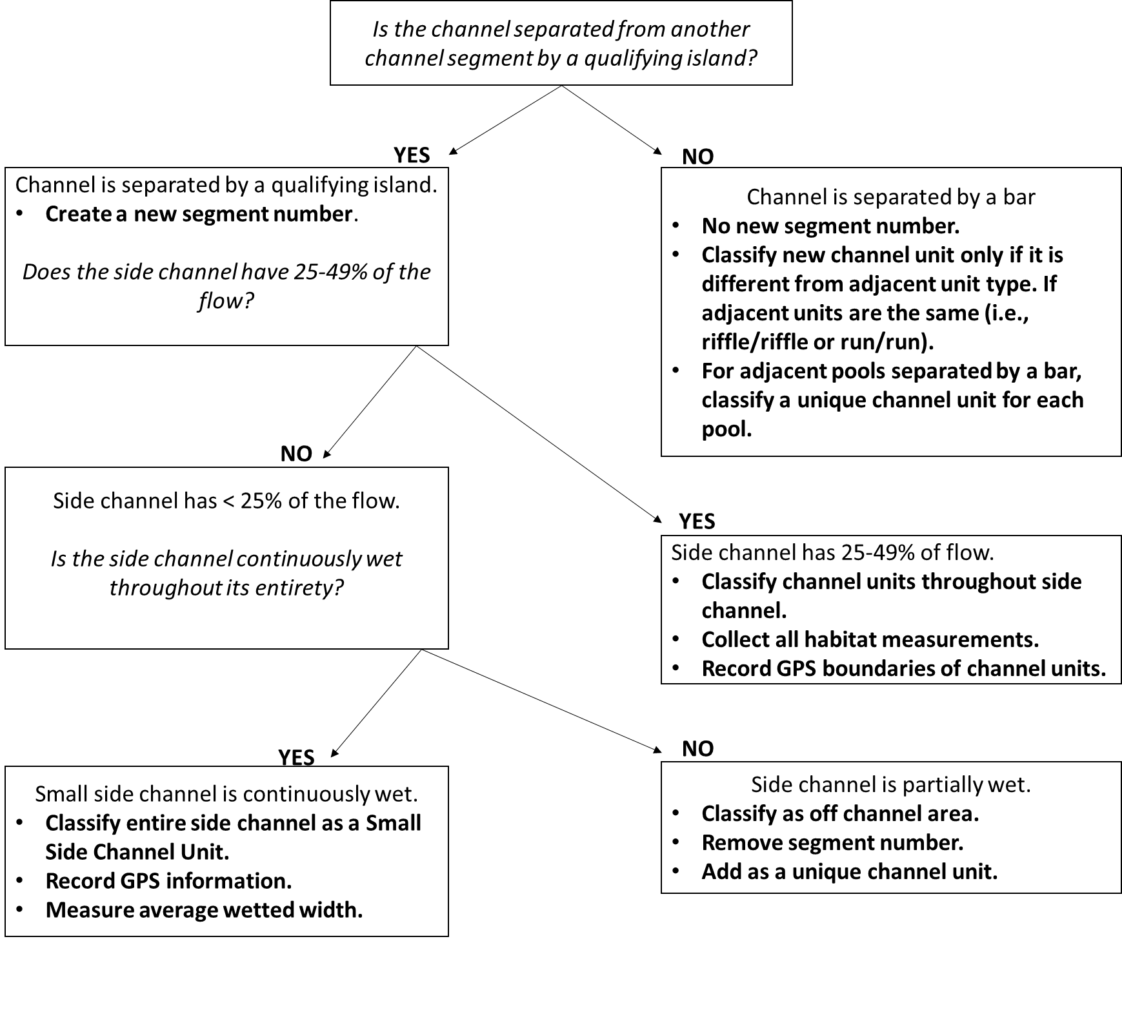

Figure 1. Decision tree outlining segment number and channel unit designations adapted from CHaMP (2016).

C:\Users\richi\AppData\Local\Microsoft\Windows\INetCache\Content.Word\Unit_Segment.tif

**S4 U28**

**S1 U27**

Figure 2. How to number channel segments within a site. The main channel is assigned segment 1 throughout the site. Both large and small side channels are assigned sequential segment numbers working upstream. In the figure, channel segment numbers are preceded with a “S” (S1-S3) and channel unit numbers with a “U” (U1-U13). Adapted from CHaMP (2016).

# Channel Unit Delineation

**Objective:** Delineate channel unit boundaries and classify channel units.

**Equipment:** Flagging, sharpie, depth rod, tablet, GNSS receiver.

The interactions among stream flow, sediment load, and channel resistance contribute to the formation of distinct areas (units) within the stream channel. These channel units, as a result, can be distinguished by their morphology (gradient, depth, shape), hydraulic properties (velocity & turbulence), and bed roughness (substrate size). Many fish habitat attributes are measured at the channel unit level.

Channel units are distinguished by gradient, relative stream velocity/flow, and/or turbulence and include six classes: Pool, Run, Riffle, Rapid +, Small Side Channel, and Off Channel.

Below is a general definition of each class:

* **POOL:** Channel units are topographical low points in the bed profile that feature very low gradients, smooth laminar flow, and possess lateral and longitudinal concavity (Figure 3). Gradient 0 – 1%.
* **RUN:** Feature low gradients, dominantly sand to cobble substrate, and smooth laminar flow. Often, runs contain a gentle slope, like pools, but are distinguished from pools by their general lack of lateral and longitudinal concavity. Runs are generally deeper than riffles. Gradients < 1%.
* **RIFFLE:** Riffles are topographical high points in the bed profile that feature moderate to steep gradients, typically cobble/gravel substrate, and tend to have consistently turbulent flow and a laterally broad uniform bedform. The bedform of riffles generally lacks longitudinal and/or lateral concavity (Figure 3). Gradients 1 – 4%.
* **RAPID +:** The rapid + channel unit includes rapids, cascades, and falls. All rapid + channel units are characterized by steep gradients, coarse substrate, and tend to have consistently turbulent flow. Rapids typically contain boulder and cobble substrate, lack bedform concavity, and have gradients 4 – 8%. Cascades feature a series of chutes and hydraulic jumps organized in a step pool sequence whereas falls are an abrupt, high gradient drop over bedrock, large boulders, or a dam. Cascades and falls have a gradient > 8%.
* **SMALL SIDE CHANNEL:** Small side channels are channels that split from the main channel and contain <25% of the total stream flow.
* **OFF CHANNEL:** Off channel units include partially wet side channels, backwaters, and alcove type units that are connected to the main channel or side channels but have little (< 1%) to no flow through them. The thalweg never passes through Off Channel units.

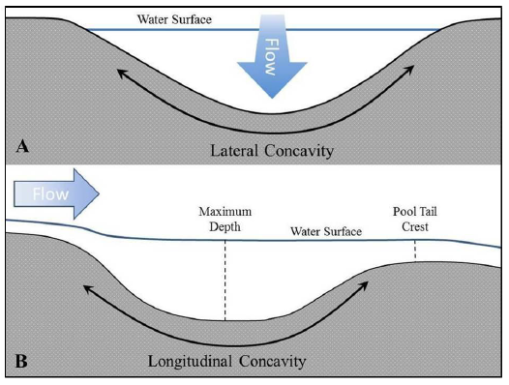

Figure 3. Representation of pool A) cross-sectional (lateral) and B) longitudinal concavity.

## Channel Unit Delineation Steps

**Objective:** Locate and classify all unique channel units throughout the site.

1. Identify channel units and their boundaries.
   1. Use the following criteria as a guide when identifying distinct channel units. In general, channel units are at least as long as the average wetted channel width. In larger streams, channel units may be shorter than the average wetted channel width.
   2. Channel units are relatively homogenous, localized areas of the stream channel characterized by four elements:
      1. Water surface gradient
      2. Bedform (concavity)
      3. Bed material composition
      4. Flow characteristics (e.g., velocity, turbulence)
   3. Look for distinct changes in these elements to determine unit boundaries (Figure 4). Use the descriptions found in Table 2 as well as the dichotomous keys to assist in classifying all channel units (Figure 5). Classification trees are read from top to bottom.
2. Flag the unit boundaries and assign a unique number to each unit, which begins with the stream segment number (e.g., S1 U1, S1 U2, etc.) working in a consistent down or upstream direction. If the channel unit boundary does not run roughly perpendicular to the flow field, multiple flags may be hung to properly delineate the unit boundary to the ensuing fish and/or habitat data collection crews.
3. Collect GPS location measurements at the top of each flagged channel unit boundary. If the boundary is complex, collect multiple GPS locations to properly delineate the unit boundary. Ensure that GPS coordinates are collected at the left and right wetted bank of the unit boundary in addition to the in-channel boundary. Record the correct channel unit number and type for each GPS location.

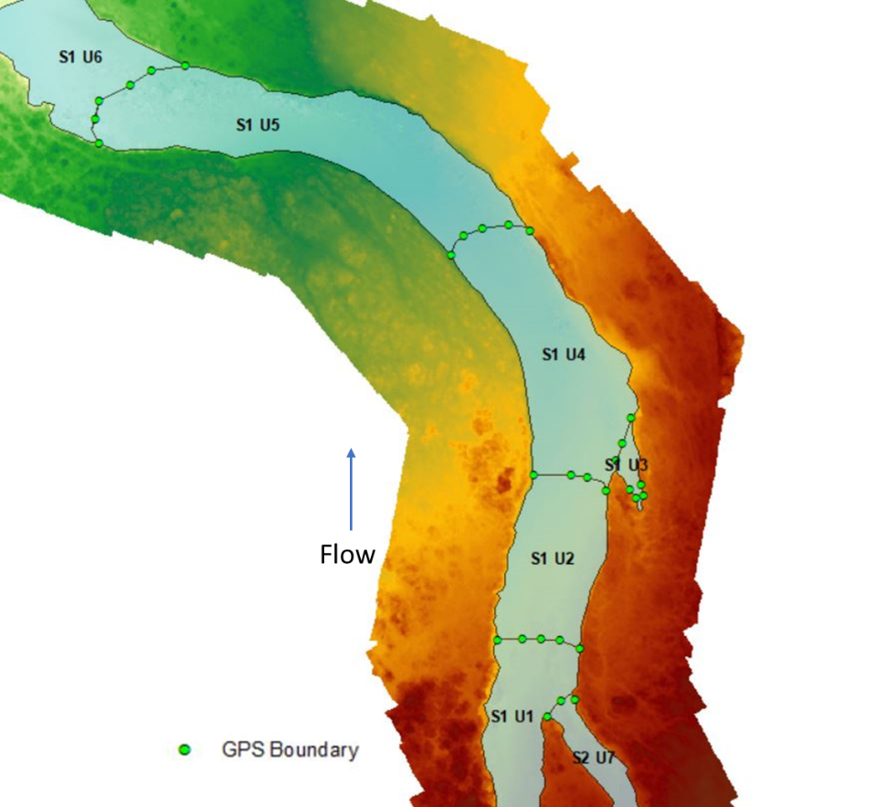

Figure 4. Channel unit perimeter delineation. Adapted from CHaMP (2016).

Table 2. Criteria used to delineate and classify channel units.

|  |  |  |  |  |
| --- | --- | --- | --- | --- |
| **Tier 1 Classification** | **Gradient** | **Bedform Profile** | **Substrate Composition** | **Flow Character** |
| **Pool** | 0 – 1% | Pools are laterally and longitudinally concave (Figure 3) | Variable, generally smaller sorted substrate | Generally laminar flow |
| **Run** | 0 – 1% | Distinguished from pools by their general lack of lateral and longitudinal concavity; uniform depth | Sand to cobble substrate | Smooth, laminar flow, minimum surface turbulence |
| **Riffle** | 1 - 4% | Topographic high points in bed profile, laterally broad bedform | Gravel to cobble substrate | Consistently turbulent flow |
| **Rapid +** | > 4% | Lacks longitudinal and/or lateral concavity | Typically, coarse substrate (cobbles and boulders) | Fast, turbulent flow |
| **Small Side Channel** | NA | NA | NA | NA |
| **Off Channel** | 0 – 1% | Typically flat and homogenous | Gravel, sand, and fines | Little to no flow |

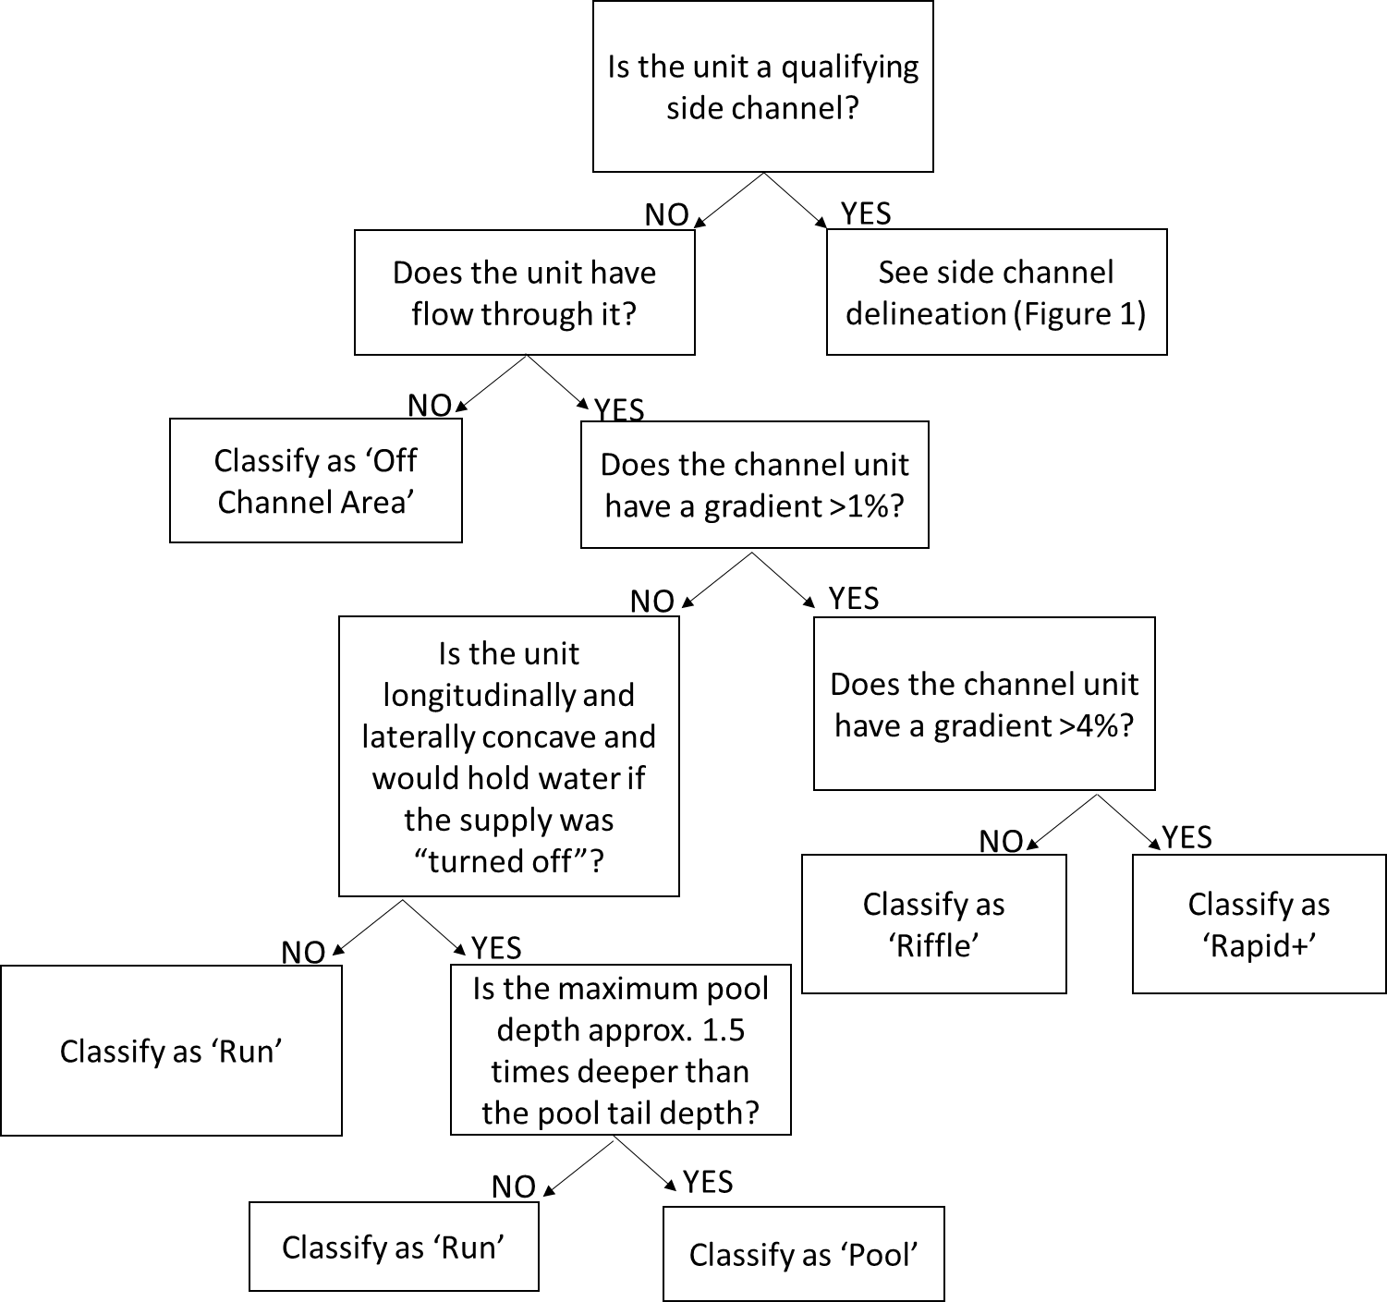

Figure 5. Dichotomous key of criteria used to classify Tier I (Off Channel Area, Run, Pool, Riffle, Rapid+) channel units. Adapted from CHaMP (2016).

# Habitat Data Collection

On the ground habitat data collection will primarily be conducted at the channel unit level. Each individual delineated channel unit will have corresponding habitat measurements. Starting at the now established top of site (or bottom in accordance with fish data collection) location, crews will begin collecting habitat measurements moving downstream (or up depending on appropriate workflow).

## Large Woody Debris

Ground crews will document, inventory, and measure qualifying large pieces of wood within each channel unit. Crews will collect data from pieces of wood where the majority of the piece lands within the bankfull channel ‘prism’ as described in CHaMP (2016). Each individual piece will be associated with the individual channel unit that it falls in.

**Objective:** Quantify and assess the number and dimensions of qualifying LWD pieces for each channel unit within the site.

**Equipment:** Depth rod, tape measure (optional), range finder, tablet.

1. Identify qualifying LWD within the bankfull channel and prism.
   1. LWD and root wads must be dead with the exception of newly fallen trees that are uprooted from the bank but still have green foliage.
   2. LWD size qualifications:
      1. Must have a b-axis (second longest axist) diameter ≥ 15 cm, measured at the midpoint of the piece. For LWD with attached roots, the diameter is measured at the midpoint between where the main stem joins the root mass (i.e., root collar) and the top of the piece (Figure 6).
      2. Must be ≥ 1.5 m in length. The length of LWD with attached roots is measured from the end of the main root mass to the top of the trunk.
      3. The majority of the qualifying LWD piece must fall within the bankfull channel or bankfull prism\*.

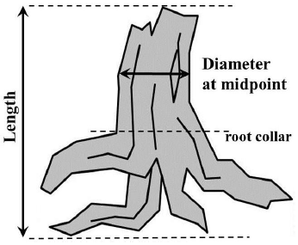

Figure 6. Depiction of diameter and length measurements locations for LWD with attached roots.

\*The bankfull prism refers to the area directly above the bankfull channel elevation. Classify pieces outside the bankfull channel, but within the bankfull prism if they meet both of the following criteria.

* + 1. Piece is in the bankfull prism and is suspended vertically above the bankfull channel by other pieces of LWD.
    2. Piece would fall into the bankfull channel if the supporting LWD was removed. Note: These pieces frequently occur in large wood aggregates or “jams”. (If a jam is encountered, proceed to step 5).
  1. For LWD embedded in the stream bank, the exposed portion must meet the minimum length and diameter requirements to qualify. Quantify the length and diameter of the exposed portion of the piece.
  2. If a LWD piece is broken or cracked, consider it one piece if the two pieces are attached at any point along the break.

1. Record the length and diameter of qualifying LWD pieces.
   1. Measure and record the length and diameter of the first 10 qualifying LWD pieces encountered at each channel unit.
   2. Estimate and record the length and diameter of the next 9 LWD pieces and measure the 10th. Repeat this process of measuring every 10th piece (#20, #30, #40, etc.) until all qualifying pieces have been quantified.
   3. In addition to measuring pieces described in steps a. and b. above, also measure the first 10 LWD pieces that are ≥ 15 m long.
   4. Record length to the nearest 0.1 m, and diameter measurements to the nearest 1 cm.
   5. If a piece cannot be measured accurately, estimate the length and diameter and measure a different qualifying piece.
2. Assign qualifying LWD pieces to a channel unit.
   1. Assign each piece of LWD to one channel unit. If a piece of LWD is present in two or more channel units, assign it to the unit that contains the highest proportion of the piece’s volume.
   2. Tally all qualifying LWD pieces within the entire bankfull channel including those pieces within all qualifying side channels.
3. Determine if pieces crossing the bottom / top of site boundaries qualify.
   1. A LWD piece that crosses the bottom / top of site boundary qualifies if it meets the size criteria (Step 1), and a majority of the piece falls within the bankfull channel prism (Step 1.b.iii)
4. Determine if a conglomerate of more than 5 pieces of wood qualify as a jam.
   1. If five or more qualifying pieces of wood are touching in any place, they are determined to be a jam.
   2. Estimate the total length, width, and depths of jams.
   3. Estimate the number of qualifying pieces within each jam and record the information.

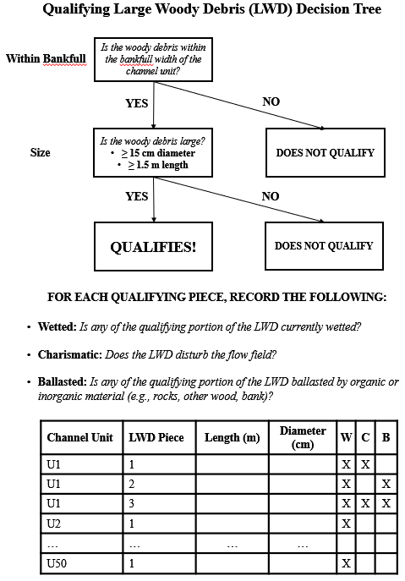

Figure 7. Decision tree to evaluate whether wood debris qualified as qualifying large woody debris (LWD). Also shown are data to collect from individual LWD pieces.

## Undercuts

Undercuts will be measured and documented according to CHaMP (2016). Each qualifying undercut will be assigned the appropriate channel unit number. If the undercut spans multiple channel units, the undercut will be split at the channel unit boundary and treated as separate undercuts.

**Objective:** Quantify undercut banks in the main channel and qualifying side channels.

**Undercut Banks Equipment:** Depth rod, tablet.

1. Identify qualifying undercut banks.
   1. Undercut banks are continuous cave-like features in the stream bank formed by overhanging bank material and/or tree roots.
   2. Qualifying undercut banks:
      1. Provide fish cover at the time of sampling.
      2. Have a width ≥ 20 cm.
      3. Are ≥ 1 m long, measured along the edge of water.
      4. Include undercuts with ceilings ≤ 1 m above the water surface.
2. Estimate the length of the undercut.
   1. Determine the upstream and downstream boundaries of the undercut and measure the length along the edge of water.
   2. Only measure the portion of the undercut that meets the minimum width requirement (Step 3).
   3. When there are two or more qualifying undercuts separated by a distance of less than 0.5 m, consider them one undercut but do not account for the distance between them in the length estimate.
3. Measure and record the width of qualifying undercuts.
   1. Measure the wetted widths of the undercut parallel to the water’s surface and perpendicular to the direction of flow.
   2. Undercut width is measured as the wetted horizontal distance from the outermost edge of the overhanging bank to the back “wall” of the undercut at its widest point.
   3. Measure undercut widths at 3 points located at 25, 50 and 75% of the qualifying undercut length. The average width of the three points must be ≥ 20 cm to qualify.
4. Assign qualifying undercuts to their corresponding channel unit and stream bank.
   1. Record the channel unit that the undercut falls within.
   2. Assign each undercut to the corresponding stream bank (left/right bank or island).
   3. Some undercuts extend between two channel units:
      1. If a single undercut extends between two channel units, consider it two distinct undercuts separated at the channel unit boundary. Each individual undercut must meet length and width requirements.
      2. If a single undercut extends between two channel units and one of the portions does not meet the minimum length requirement, consider it one undercut and assign the undercut to the channel unit that contains the greater proportion of its length. Similarly, if a single qualifying undercut extends between two channel units but neither portion qualifies based on length, consider it one undercut and assign it to the unit with the greater proportion.

## Substrate Composition

Substrate composition will be measured or estimated for all channel unit types except rapid+. Substrate is difficult to reliable estimate in rapid+ channel units due to safely reasons (in the case of pebble counts) and difficulty seeing the substrate (in the case of ocular estimates). Beginning in 2019, ocular substrate estimates will be recorded in all channel unit types except rapid+, including pool, run, riffle, small side channel, and off-channel following methods defined by CHaMP (2016). In addition to ocular estimates, pebble counts will be collected in the first 10 riffles of each DASH survey location following CHaMP (2016).

### Ocular Substrate Estimates

Within pool, run, riffle, small side channel, and off-channel area channel unit types, the overall substrate composition will be estimated using ocular methods, following CHaMP (2016). Substrate composition will be estimated using five categories: sand/fines, gravel (including coarse and fine), cobble, boulder, and bedrock. Coverage for each category will be estimated and rounded to the nearest 10%.

**Objective:** Visually estimate the substrate composition of each slow water channel unit (pool, run), fast water channel unit (riffles only), small side channels, and off channel areas and record the percentage of each size class.

**Ocular Substrate Composition Equipment:** Tablet

1. Estimate the percentage of each substrate size class.
   1. Visually survey the substrate composition of each channel unit and record the percentage of each substrate class within the wetted surface area.
   2. Round estimates to the nearest 10%.
   3. You may not be able to see the entire wetted surface area of a channel unit due to visual obstructions (aquatic vegetation, wood, water turbation, or other debris). When this occurs, estimate the area you can see.
   4. The total of all classes should equal 100%.
   5. If a thin layer of fine sediment is covering a larger particle, then measure the fine sediment, not the larger particle. Conversely, if individual fine sediment particles are resting on top of a larger rock; measure the rock.

Table 3. Ocular substrate size classes. Estimate b-axis diameter of particles.

|  |  |  |
| --- | --- | --- |
| **Substrate Type** | **Size Class (mm)** | **Description** |
| Boulders | > 256 | Basketball size and greater |
| Cobbles | 64 – 256 | Tennis ball to basketball size |
| Gravel | 2 – 64 | Ladybug to tennis ball size |
| Sand | 2-0.002 | Smaller than ladybug size |
| Fines | < 0.002 | Smaller than sand |

### Pebble Cross Sections

Pebble cross sections will be completed for the first 10 riffle channel units within each DASH survey location following methods described in CHaMP (2016).

Step 1. Place cross sections.

* 1. Place a single cross-section at the midpoint of each riffle channel unit.
  2. Cross-sections should not cross channel unit boundaries.

1. Select 11 sampling points at each cross-section.
   1. At each cross-section, visually divide the cross-section into 11 equally spaced sampling points running perpendicular to the stream channel and spanning the width of the wetted channel (Figure 8).
2. Select and measure particles.
   1. Select particles at sample points by turning your eye away and extending your finger down and picking up the first particle that you feel at the tip of your boot.
   2. Use a gravelometer (Figure 9) to classify the b-axis of each particle. Record the size category (Table 3) for the largest square opening that the particle does not fit through. For example, if the particle fits through the 180 mm square, but does not fit through the 128 mm square it is classified as the 128-180 mm size class.
   3. Record silt and clay particles that are < 0.06 mm in the 0.0002-0.06 mm size class. Silt and clay particles are smooth when rubbed between the thumb and fingers whereas sand rolls between the fingers (is gritty).
   4. Use the thin edge of the gravelometer to determine sand particles between 0.06 and 2 mm. Note the thin edge of the gravelometer is 2 mm wide.
   5. For particles > 128 mm and < 512 mm, measure the b-axis using the notches at the top of the gravelometer.
   6. For particles > 512 mm, measure and record the length of the b-axis using the top edge of the gravelometer or a depth rod.
   7. Record ‘bedrock’ when encountered at sample points.
   8. If your finger touches a thin layer of fine sediment covering a larger particle, then measure the fine sediment, not the larger particle. Conversely, if your finger touches a rock covered by individual fine sediment particles; measure the rock.
   9. **Do not measure stream bank particles.**
   10. For embedded particles that cannot be removed from the stream bed, used the notched end of the gravelometer or the depth rod to measure the b-axis, and record the appropriate size class.

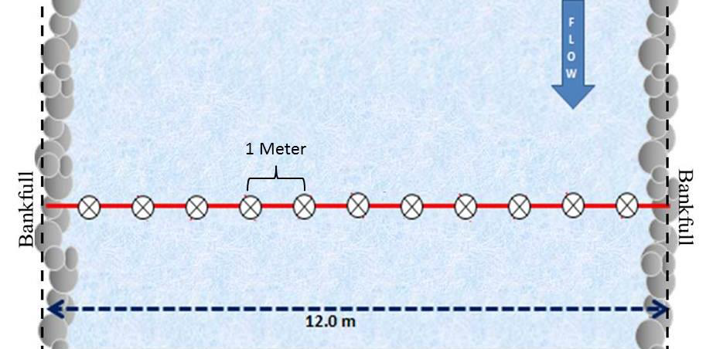

Figure 8. Example of a cross-section layout. In this example, distance between samples is 1 m, because the bankfull width is 12 m. Particle sample location is shown with a circle and crosshairs. Figure from CHaMP 2016.



Figure 9. Gravelometer used to classify the b-axis of particles.

Table 4. Size categories for sediment in the range of silt/clay to bedrock. Record the size range that the particle falls within (e.g., 45-64). Adapted from CHaMP (2016).

|  |  |  |  |
| --- | --- | --- | --- |
| **Description of Particle Size** | | **Size Range (mm)** | |
| **Lower** | **Upper** |
| **Bedrock** |  | NA | NA |
| **Boulder** | Mega | >4000 | NA |
| Very Large | 2896 | 4000 |
| 2048 | 2896 |
| Large | 1448 | 2048 |
| 1024 | 1448 |
| Medium | 724 | 1024 |
| 512 | 724 |
| Small | 362 | 512 |
| 256 | 362 |
| **Cobble** | Large | 180 | 256 |
| 128 | 180 |
| Small | 90 | 128 |
| 64 | 90 |
| **Gravel** | Very Coarse | 45 | 64 |
| 32 | 45 |
| Coarse | 22.6 | 32 |
| 16 | 22.6 |
| Medium | 11.3 | 16 |
| 8 | 11.3 |
| Fine | 5.7 | 8 |
| 4 | 5.7 |
|  | Very Fine | 2 | 4 |
| **Sand/Fines** |  | 0.0002 | 2 |

### Depth Measurements

Both the maximum depth and the thalweg exit depth, where the thalweg exits the channel unit at the downstream most extent will be measured. The maximum depth will be measured within all channel unit types excluding small side channels and the thalweg exit depth will be measured in all channel units excluding small side channels and off channel areas.

**Objective:** Measure and record the maximum depth of each channel unit and the thalweg exit depth at the location that it exits the channel unit at the downstream most extent.

**Equipment:** Depth rod, handheld GPS, tablet.

Step 1. Locate and measure the single deepest portion of each applicable channel unit and record that value in meters.

Step 2. Locate the downstream extent of the channel unit and the portion of that unit with the deepest, fastest flow (greatest amount of flow) and record the depth of that location in meters.

### Wetted fish cover

The total percent of each individual channel unit and small side channel covered will be estimated and recorded. Fish cover is any material within the wetted channel consisting of woody debris, aquatic vegetation cover, overhanging vegetation, or manmade cover that is within the wetted channel and within 1m above the wetted surface elevation.

**Objective:** Estimate the total percent fish cover present at each individual channel unit.

**Equipment:**  Tablet

1. Visually estimate the total percent of the wetted area of the channel unit covered.
   1. Estimate and record the percent of the channel covered by overhanging vegetation cover, aquatic vegetation, woody debris, and artificial cover.
   2. Visually estimate the percent of the wetted area that has no fish cover and record your estimate.
      1. If different cover types overlap treat them independently, do not add or conglomerate different cover types.
      2. The total cover can be equal to greater than 100% if multiple cover types overlap. For example, overhanging vegetation overlapping aquatic vegetation.
      3. When estimating total no cover, treat the estimate independent from all other fish cover estimates.

### Discharge Measurements

Discharge will be measured at the top and bottom of each site, in addition to any location where a tributary, diversion, or diversion return removes/contributes at least 25% of the total estimated flow. Depth and velocity measurements are made at one carefully chosen channel cross-section. It is important to choose a channel cross-section that is as much like a canal as possible to get the best estimate of the amount of water flowing through the site. A Run type channel unit with a U-shaped channel cross-section that is free of obstructions provides the best conditions for measuring discharge. You may remove rocks and other obstructions to improve the cross-section before any measurements are made. At smaller streams during low flows, velocity with a flow meter may be impossible to measure.

**Objective:** Quantify the total discharge entering and exiting the site. Further, quantify any point(s) within the site where the discharge either increase or decreases by at least 25% (excluding side channels).

**Equipment:** Velocity meter, tape measure, pins, topset rod, tablet.

1. Identify cross-section location.
   1. Locate a cross-section in the stream channel that has most of the following qualities:
      1. Segment of stream above and below the selected cross-section is straight.
      2. Depths are mostly greater than 15 cm, and velocities are mostly greater than 0.15 m/s. Do not measure discharge in a pool.
      3. "U" shaped channel with a uniform streambed free of large boulders, woody debris or brush, and dense aquatic vegetation.
      4. Flow is relatively uniform with no eddies, backwaters, or excessive turbulence.
      5. Is located near the top of site, bottom of site, or diversion/return.
   2. If an appropriate cross-section location cannot be identified within a site, extend the search upstream or preferably downstream of the site boundary, avoiding locations that would differ in flow from that of the site such as entry areas of tributaries and side channels within the site extent.
2. Set up cross-section and identify measurement locations.
   1. Stretch and secure a meter tape across the stream perpendicular to the flow with the “zero” end on the left bank (looking downstream).
   2. Divide the total wetted stream width into 15 to 20 equally spaced intervals (Figure 10).
      1. To determine each interval width, divide the total wetted width by 20 and round up to a convenient number (e.g., nearest tenth or half meter).
      2. Intervals should not be spaced less than 10 cm apart, even if this results in less than 15 intervals.



* + 1. Take the first depth and velocity measurement at the left edge of water. Conduct the second measurement one interval out from the left bank and continue measurements at each interval. The last depth and velocity measurement will be at the right edge of water.

1. Measure width, depth, and velocity for each station.
   1. Stand downstream of the velocity meter when taking measurements.
   2. If the depth is 0, which it likely should be at both the left and right banks, record the velocity as 0.
   3. If the velocity is negative (-), record the measured velocity.
   4. At each station, record the station width as the distance from the previous station to the current one, starting with the left bank.
      1. For the first, left bank, the station width should be zero, as should likely be the depth and velocity.
      2. For the last, right bank, the station width may be different and will be the distance from the last wetted station to the edge of the wetted width. In this case, the depth and velocity should also likely be zero. If the distance from the previous wetted station to the edge of the wetted width is less than 0, simply move the last station to the edge of the wetted width and update the station width to reflect that.
      3. The sum of the station widths should be equal to the total wetted width.
   5. Place the topset rod in the stream at the interval point and record the water depth. Set the topset rod to the correct height. This will raise or lower the velocity probe to 60% of the water depth at that interval. Position the velocity probe directly perpendicular to the stream channel and hold the topset rod vertically level. Wait for the progress on the velocity meter to go through a full 10 second cycle (i.e., fully through 0% to 100%). Record the velocity. Move to the next interval point and repeat the same procedure until depth and velocity measurements have been recorded for all intervals.

Table . Example of how to record station widths, depths, and velocities for a discharge measurement. Note that for the left bank, the station width is recorded as 0.00 and for the right bank, the station width differs from the remaining measurements. In this case, the total wetted width is 3.67 meters, the sum of the station widths.

|  |  |  |  |
| --- | --- | --- | --- |
| Station | Station Width (m) | Station Depth (m) | Station Velocity (m/s) |
| 0 | 0.00 | 0.00 | 0.000 |
| 1 | 0.25 | 0.10 | 0.042 |
| 2 | 0.25 | 0.23 | 0.088 |
| 3 | 0.25 | 0.26 | 0.625 |
| 4 | 0.25 | 0.33 | 0.824 |
| 5 | 0.25 | 0.39 | 0.868 |
| 6 | 0.25 | 0.42 | 0.875 |
| 7 | 0.25 | 0.47 | 0.800 |
| 8 | 0.25 | 0.50 | 1.055 |
| 9 | 0.25 | 0.55 | 1.019 |
| 10 | 0.25 | 0.58 | 1.197 |
| 11 | 0.25 | 0.60 | 1.193 |
| 12 | 0.25 | 0.62 | 1.272 |
| 13 | 0.25 | 0.62 | 1.195 |
| 14 | 0.25 | 0.30 | 0.503 |
| 15 | 0.17 | 0.00 | 0.000 |

# Drone Survey

**Objective:** To generate a georeferenced and scaled orthomosaic map and high resolution dense cloud and digital elevation model of the survey site.

**Equipment:** Quadcopter drone, high resolution gimble camera, handheld GPS, tablet, ground targets

1. Ground target placement and capture (optional).
   1. Ground targets will be placed throughout the survey area in co-ordinance with benchmark placement (see benchmark placement above), to geo-locate and scale the orthosmosaic and dense cloud properly.
   2. Ground targets will consist of painted black and white poster material that will be surveyed with an RTK dGPS or handheld sub meter GNSS receiver.
   3. Ground targets will be spread evenly throughout the entirety of the reach, in addition to being located at the bottom and top of site markers (again, see benchmark placement above).
   4. At minimum, 5 ground targets per 1km of site length will be installed. For example, if the sample length is 3km then a total of at least 15 ground targets will be placed for the entirety of the survey.
   5. Benchmarks will be placed at the center of the ground targets and driven into the ground with rebar and then covered with a benchmark cap.
2. Draw pre-flight paths.
   1. Flight paths will be drawn to incorporate the entirety of the main channel, off channel habitat, and any area considered within the active bankfull channel. Ensure a buffer distance around the active bankfull channel such that no habitat within the reach is missed during the survey.
   2. If the active bankfull channel and qualifying side channels extend a great distance into the flood plain, capture of those areas may be done with a greater flying altitude.
   3. Ensure that the flying altitude is great enough to not contact vegetation.
3. Deploy quadcopter drone with a high resolution Gimble camera attached.
   1. Initial imagery will be collected at a maximum flying altitude of 100m for the entirety of the survey.
   2. Main channel, and off channel image collection altitude will be determined by the estimated average wetted width of the site sampled and the total length of the site.
   3. Images will be collected with a 70% front overlap and 60% side overlap.
   4. Ensure that each planned flight path leaves enough battery life to return to the base deployment location.
   5. Mark each location within the flight path where the drone returned to the home location, to ensure that location can properly be revisited.
   6. Ensure that section of flight paths overlaps the next section for merger of drone generated products during post processing.

### Wetted Cover (drone supported)

**Objective:** To visually estimate the overall amount of cover the wetted channel exhibits at the time of sampling at each individual channel unit and side channel.

**Equipment:** GIS, continuous drone imagery and channel unit polygons.

Total wetted cover can be estimated from processed drone imagery combined with spatially explicit channel unit boundaries collected with the GNSS receiver in the field. Estimate the percent of the wetted channel covered by any overhanging material including; vegetation, woody debris, ice, manmade cover (bridges, culverts), etc. Riparian cover will be rounded to the nearest 10%. If the channel has less than 5% cover round to 0, if the channel has 5% or greater cover round to 10% and so on. Cover can be of any height from the water surface, including understory or canopy cover. If cover overlaps, only estimate the amount of channel covered, do not count any single area of cover multiple times. Estimate cover at each individual channel unit within the main channel and estimate cover across each individually marked side channel including large and small side channels.

Note: As drone and computational technology increases, there is potentially that the main channel will be surveyed three times following the centerline of the wetted channel at time of surveying. The camera will be fixed perpendicular to the water surface for one flight, fixed at a 45-degree angle facing the left bank for a second pass, and fixed at a 45-degree angle at the river right bank for the third pass.

# References

CHaMP (Columbia Habitat Monitoring Program). 2016. Scientific protocol for salmonid habitat surveys within the Columbia Habitat Monitoring Program. Prepared by CHaMP for the Bonneville Power Administration.

Harrelson, C.C., C.L. Rawlins, and J.P. Potyondy. 1994. Stream channel reference sites: an illustrated guide to field technique. USDA Forest Service, Rocky Mountain Forest and Range Experiment Station, General Technical Report RM-245, Fort Collins, CO.

Leopold, L.B., M.G. Wolman, and P. Miller. 1964. Fluvial Processes in Geomorphology. W.H. Freeman and Company. 522 p.

# Appendix A. Habitat Metrics

Appendix Table 1. Summary of habitat metrics collected using the DASH protocol. Includes summary of scale that each habitat metric can be collected at and collection methods that can be used to collect each metric.

| **Metric** | | **Scale** | | **Collection Method** | | | |
| --- | --- | --- | --- | --- | --- | --- | --- |
| **Channel Unit** | **Reach** | **Drone** | **Green LiDAR** | **Red LiDAR** | **Ground Crew** |
| ***Channel Unit*** | |  |  |  |  |  |  |
|  | Tier 1 Channel Unit |  |  |  |  |  |  |
|  | Total Area |  |  |  |  |  |  |
|  | Total Volume |  |  |  |  |  |  |
|  | Max Depth |  |  |  |  |  |  |
|  | Residual Depth |  |  |  |  |  |  |
|  | Channel Unit Areas |  |  |  |  |  |  |
|  | Channel Unit Percentages |  |  |  |  |  |  |
| ***Complexity*** | |  |  |  |  |  |  |
|  | Wetted Depth SD |  |  |  |  |  |  |
|  | Wetted Width to Depth Ratio Avg |  |  |  |  |  |  |
|  | Bankfull Width to Depth Ratio Avg |  |  |  |  |  |  |
|  | Gravel Bar Count |  |  |  |  |  |  |
|  | Sinuosity |  |  |  |  |  |  |
|  | Wetted Channel Braidedness |  |  |  |  |  |  |
|  | Bankfull Channel Braidedness |  |  |  |  |  |  |
| ***Cover*** | |  |  |  |  |  |  |
|  | Structure Orientation |  |  |  |  |  |  |
|  | Associated Features |  |  |  |  |  |  |
|  | Percent Obstruction |  |  |  |  |  |  |
|  | Fish Cover: Terrestrial Vegetation |  |  |  |  |  |  |
|  | Fish Cover: Artificial |  |  |  |  |  |  |
|  | Fish Cover: LW |  |  |  |  |  |  |
|  | Fish Cover: Total |  |  |  |  |  |  |
|  | Total Undercut Area |  |  |  |  |  |  |
|  | Percent Undercut by Area |  |  |  |  |  |  |
|  | Percent Undercut by Length |  |  |  |  |  |  |
| ***Riparian*** | |  |  |  |  |  |  |
|  | Riparian Cover: Big Tree |  |  |  |  |  |  |
|  | Riparian Cover: Coniferous |  |  |  |  |  |  |
|  | Riparian Cover: Ground |  |  |  |  |  |  |
|  | Riparian Cover: Woody |  |  |  |  |  |  |
|  | Riparian Cover: Understory - None |  |  |  |  |  |  |
| ***Side Channel*** | |  |  |  |  |  |  |
|  | Wetted Side Channel Width |  |  |  |  |  |  |
|  | Side Channel Area |  |  |  |  |  |  |
|  | Bankfull Side Channel Width |  |  |  |  |  |  |
|  | Wetted Side Channel Percent By Area |  |  |  |  |  |  |
|  | Side Channel Area Percent |  |  |  |  |  |  |
|  | Side Channel Frequency |  |  |  |  |  |  |
|  | Side Channel Count |  |  |  |  |  |  |
|  | Side Channel Volume |  |  |  |  |  |  |
| ***Size*** | |  |  |  |  |  |  |
|  | Gradient |  |  |  |  |  |  |
|  | Wetted Width Avg |  |  |  |  |  |  |
|  | Residual Pool Depth |  |  |  |  |  |  |
|  | Wetted Volume |  |  |  |  |  |  |
|  | Depth Thalweg Avg |  |  |  |  |  |  |
|  | Cumulative Drainage Area |  |  |  |  |  |  |
|  | Bankfull Depth Avg |  |  |  |  |  |  |
|  | Bankfull Depth Max |  |  |  |  |  |  |
|  | Bankfull Width Avg |  |  |  |  |  |  |
| ***Substrate*** | |  |  |  |  |  |  |
|  | Substrate Est: Boulders |  |  |  |  |  |  |
|  | Substrate Est: Coarse and Fine Gravel |  |  |  |  |  |  |
|  | Substrate Est: Cobbles |  |  |  |  |  |  |
|  | Substrate Est: Sand and Fines |  |  |  |  |  |  |
|  | Substrate: D16 |  |  |  |  |  |  |
|  | Substrate: D50 |  |  |  |  |  |  |
|  | Substrate: D84 |  |  |  |  |  |  |
| ***Temperature*** | |  |  |  |  |  |  |
|  | Elevation (m) |  |  |  |  |  |  |
|  | Solar Access: Summer Avg |  |  |  |  |  |  |
| ***Velocity*** | |  |  |  |  |  |  |
|  | Velocity |  |  |  |  |  |  |
| ***Water Quality*** | |  |  |  |  |  |  |
|  | Conductivity |  |  |  |  |  |  |
| ***Wood*** | |  |  |  |  |  |  |
|  | Large Wood Count |  |  |  |  |  |  |
|  | Large Wood Volume |  |  |  |  |  |  |